“CHEMISTRY OF SOFT DRINKS AND ITS STATISTICAL ANALYSIS IN INDIAN ECONOMY ”
(19/03/2018 TO 25/03/2018)
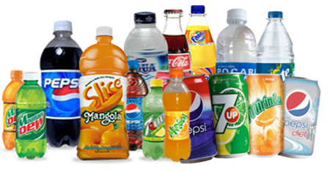
UGC:HRDC SAURASHTRA UNIVERSITY, RAJKOT
RUSA SPONCERED FIP No. – 08
DESIGN & DEVELOPMENT OD E-CONTENT WITH MULTIU-DISCIPLINARY APPROACH
GROUP NO. 01

Dr. B.J. GANGANI
r-18
CHEMISTRY DEPT.,
H & HB KOTAK INSTITUTE OF SCIENCE
RAJKOT
DR. N. M. PATIL
r-01
GEOGRAPHY DEPT.,
DOODHSAKHAR MAHAVIDYALAYA
Bidri, Kolhapur
Dr. D. H. LODHIYA
r-05
ECONOMICS DEPT.,
BAHAUDDIN ARTS COLLEGE
JUNAGADH
DR. M. R. SOLANI
r-21
STATISTICS DEPT.,
GOVERNMENT COMMERCE COLLEGE
JAMANAGAR

Introduction
While the term "soft drink" is commonly used in product labeling and on restaurant menus, in many countries these drinks are more commonly referred to by regional names, including carbonated beverage, cool drink, cold drink, fizzy drink, fizzy juice, lolly water, pop, seltzer, soda, soda pop, tonic, and mineral. Due to the high sugar content in typical soft drinks, they may also be called sugary drinks. The era of cold drinks began in 1952 but the industrialization in India marked its beginning with launching of Limca and Goldspot by parley Groups of companies. Since, the beginning of cold drinks was highly profitable and luring, many Multinational companies launched their brands in India like Pepsi and Coke. Now days, it is observed in general that majority of people viewed Sprite, Miranda,maza and Limca, to give feeling of lightness, while Pepsi and Thumps Up to activate pulse and brain.

Chemistry of soft drink:

Cold drinks of different brands are composed of alcohol, carbohydrates, carbon dioxide, phosphate ions used as pesticides etc. These soft drinks give feeling of warmth, lightness and have a tangy taste which is liked by everyone. Carbon dioxide is responsible for the formation of froth on shaking the bottle. The carbon dioxide gas is dissolved in water to form carbonic acid which is also responsible for the tangy taste. Carbohydrates are the naturally occurring organic compounds and are major source of energy to our body. General formula of carbohydrates is C_{X} (H₂O)_{Y}. On the basis of their molecule size carbohydrates are classified as Monosaccharide, Disaccharides and Polysaccharides. Glucose is a monosaccharide with formula C₆H₁₂O₆ .It occurs in Free State in the ripen grapes in bones and also in many sweet fruits. It is also present in human blood to the extent of about 0.1%. Sucrose is one of the most useful disaccharides in our daily life. It is widely distributed in nature in juices, seeds and also in flowers of many plants. The main source of sucrose is sugar cane juice which contain 15-20 % sucrose and sugar beet which has about 10-17 % sucrose.
The molecular formula of sucrose is C₁₂H₂₂O₁₁. It is produced by a mixture of glucose and fructose. It is non reducing in nature whereas glucose is reducing. Cold drinks are a bit acidic in nature and their acidity can be measured by finding their pH value. The pH values also depend upon the acidic contents such as citric acid and phosphoric acid.

Economics and Stastical view
The Indian soft drink market is poised to grow at an annual rate of 28-30 percent for 30 years, an industry official said today. Demand for fruit drinks and packaged juice products increased dramatically during the last ten years, while the overall market size of the soft drink market stands at a whopping Rs. 65,000 crore, Vadodara-based fruit drinks maker Manpasand Beverages' CMD Dhirendra Singh said here: "Out of that, the market size of juice or fruit drink segement is Rs 8, ..
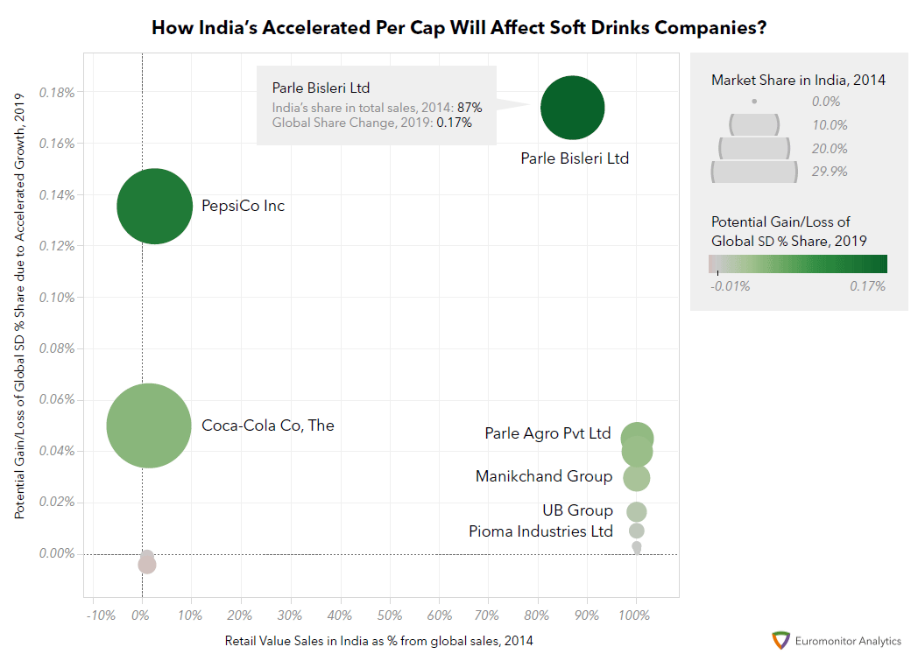
Figure shows that the local company Parle Bisleri Ltd may be the biggest winner and hugely benefit from the increase as 87% of its sales came from India in 2014. The company controlled nearly 39% of India’s bottled water sales by off-trade value in 2014 and India is its single most important market. Globally, Parle Bisleri would fetch a 0.17% share gain in overall global soft drinks under the projected extreme scenario in 2019. In 2014, Parle Bisleri was not even visible on the global soft drinks arena.

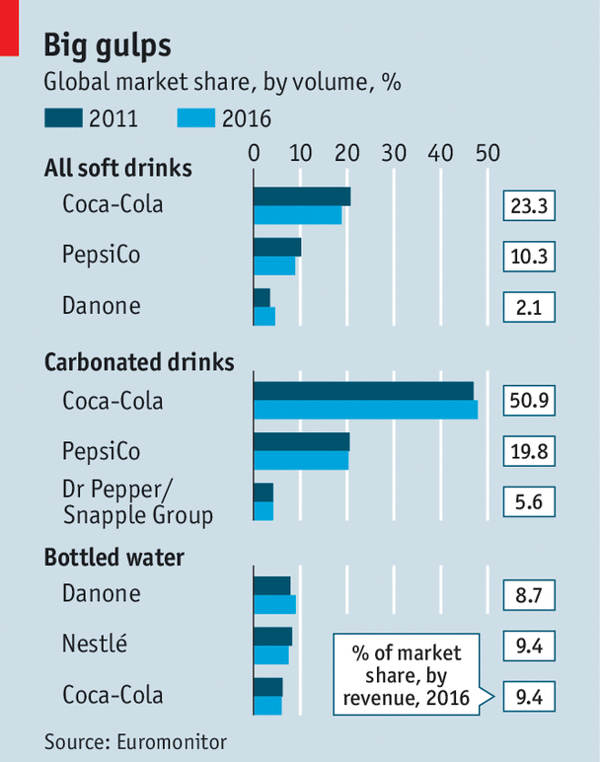

Result and discussion according to Chemistry, Economics, Stastical and Geographical Point of view in Indian

pH values: Small samples of cold drinks of different brands were taken in a test tube. The change in color of pH was noticed and was compared with the standard pH scale.

No | Soft drink | pH values & color
1 | Coca Cola | pink pH 2
2 | Sprite | Red pH 2
3 | Limca | Pinkish pH 4
4 | Fanta Light | orange pH 3

Carbon Dioxide: Among the four samples of cold drinks taken, Sprite has the maximum amount of dissolved carbon dioxide and Fanta has the minimum amount of dissolved carbon dioxide.

Disadvantages of soft drinks
1. Soft drinks are little more harmful than sugar solution. As they contain sugar in large amount which cause problems in diabetes patients.
2. Soft drinks can cause weight gain as they interfere with the body’s natural ability to
suppress hunger feeling.
3. Soft drinks have ability to dissolve the calcium so they are also harmful for our bones.
4. Soft drinks contain “phosphoric acid” which has a pH of 2.8. So they can dissolve a nail in about 4 days.
5. For transportation of soft drinks syrup the commercial truck must use the hazardous matter place cards reserved for highly consive material .
6. Soft drinks have also ability to remove blood so they are very harmful to our body.
7. Obesity and weight-related diseases.
8. Hypokalemia (low potassium levels) diseases.
Most soft drinks contain high concentration of simple carbohydrates - glucose, fructose, sucrose and other simple sugars. Oral bacteria ferment carbohydrates and produce acid, which dissolves tooth enamel during the dental decay process; thus,
Sweetened drinks are likely to increase risk of dental caries. The risk is greater if the frequency of consumption is high.
Factors which are maintain profit
Soft drinks, such as Coca-Cola, Pepsi Cola and Dr. Pepper, have been embraced by consumers around the world. The soft drink industry has expanded to include different flavors, healthier options and smaller manufacturers. However, numerous factors can affect the overall demand for soft drinks. While many of these factors are out of the control of the soft drink manufacturers, these companies must understand and adapt to these factors to maintain their profit margins.
- Price Changes
As with most goods, demand for soft drinks moves according to price. Higher the price, the lower the demand and vice versa. When soft drink companies face higher prices for their ingredients, such as sugar, high-fructose corn syrup or flavoring agents, they may choose to raise their prices to maintain their profit margins. However, the higher prices may force consumers to reduce their demand for those soft drinks. If the companies choose to hold steady on their prices, they must sell higher quantities to maintain the same profit margins.
- Consumer Preferences
Consumer preferences can change due to a wide range of reasons, including the average age of the consumer population, changes in societal trends, seasonal cycles or economic fluctuations. The success of any soft drink manufacturer hinges on that company's capability to anticipate these consumer tendencies and plan accordingly. Companies that fail to adapt to these changes can see reduced profits, lower market share and increased probability of crippling business failure
- Health Issues
The increased awareness of health-related issues, such as high blood pressure, obesity and diabetes, has raised concerns among consumers about the ingredients in many soft drinks. Soft drink manufacturers have adapted to these changes by introducing healthier options, such as sugar-free drinks, caffeine-free drinks, fruit juice-based drinks, sports drinks and bottled water. These options allow soft drink manufacturers to maintain and increase their market shares, while presenting an image of providing more than just "fizzy sugar water" to their customers.
- Other Factors
While these three factors are among the most obvious influences on the demand for soft drinks, several other events can also sway customer demand. Government regulations, such as the ban in New York City on soft drink servings larger than 16 ounces -- a law that was later ruled unconstitutional -- can curb customer demand. Manufacturers can also suffer damage to their reputations, based on news about product defects or corporate malfeasance, which can harm the demand for their products. Companies can increase demand for their drinks by introducing them into overseas markets or targeting different demographic groups.
Natural Juice market in India

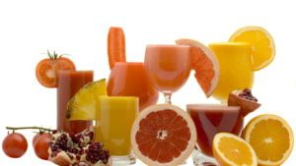
The global juice market is on a continuous increase as consumption of juices is increasing due to health issues. The juice industry is facing a two-track growth story, as it is showcasing a slower growth in developed countries where packaged juices and fresh juices are already penetrated whereas on the other side, developing countries are showing a huge potential in the juice market with their shift from carbonated to non-carbonated beverages globally.
The major segment of India’s juice market is bifurcated by the amount of fruit content in each type which comes out with fruit beverages like juice, drinks and nectar that are created using pulp content. Anything less than 100 percent concentrate is labeled as a drink, and fruit drinks are defined as calorically sweetened beverages with a small percentage of fruit juice or juice flavoring containing carbonated water.
In 2015, fruit drinks showcased a dominating share of 58 percent in the market as they come cheaper than fruit juices and nectar drinks but with increasing awareness of health issues due to consumption of such drinks is expected to see the decline of fruit drinks in the market in the coming five years. At the highest end of the juice segment – 100 percent fruit juice, a niche segment of super-premium juices is growing quickly and top players are working rigorously.
In a country like India, an unorganized segment dominates the market as juice bars and juice stalls can be seen in every nook and corner. Such fruit juices which aren’t packaged have been popular in India, but there has been a steady growth in the packaged juice market since the last few years. However, the cost for packaged juices is higher than juices that aren’t packaged, but this isn’t a major concern for juice manufacturers since India’s disposable income is steadily on the rise.
The recent past saw an absence of brand players though there is an increase and consumers are now given more choices making them more brand conscious. Current trends have shown that domestic players are competing well against multinational companies. A good sign of this is shown by smaller brands entering the overall Indian juice market. New evolving diseases have forced Indian consumers to be more aware of the kind of juices they are consuming. Fruit juices are a cheap and viable product for street vendors who serve it on the streets and Indian consumers, who are price sensitive usually go for cheaper options without realizing the side effects. Leading fruit juice manufacturers are making every effort to create awareness for consumers so that they are conscious of the harmful effects brought about by juices from unorganized players such as street vendors selling fruit juices without food safety regulations at roadsides.
USES OF COLD DRINKS
1. They can remove rust spots from chrome car Humpers.
2. They can lose a rusted bolt.
3. In many states, the highway patrol carries a few gallons of Soft Drinks in order to remove blood from the highway after auto accidents.
4. Place a T-bone steak in a bowl of Soft Drinks and it will be gone in 2-3 days. The meat is consumed by the acid of the cola.
5. Toilet Cleaning: Pour a can of Soft Drinks into the toilet bowl and let the "real thing" sit for one hour, then flush. It magically cleans better than if you had scrubbed it. The citric acid in Soft Drinks also removes stains from vitreous china.
6. Clean corrosion from car battery terminals: Pour Soft Drinks over the terminals and the ultra-acid soft drink bubble away the alkaline corrosion in seconds.
7. Remove grease from clothes: Empty a can of Soft Drinks into a load of greasy clothes, add detergent, and run through a regular cycle. The Soft Drinks will help loosen grease stains. It is also an excellent cleaner road haze from your windshield.
8. The active ingredient in Soft Drinks is phosphoric acid. Its pH is 2.8. It will dissolve a nail in about 4 days.
9. To transport Soft Drinks syrup (the concentrate) the commercial truck must use the
Hazardous material place cards reserved for highly corrosive materials.
10. The distributors of Soft Drinks have been using it to clean the engines

Roots of soft drink in Indian market
The first brand of soft drink Gold spot established 53 years ago. Before all empowering Coca-Cola entered the country to dominate the soft drink market, the history of soft drink in India is quite drinking old. Down the ages, people consume soft drink to give them a refreshing feeling. Gold spot is considered as the first brand of soft drink in India, it was introduced in 1965. Coca- cola at the same time entered the Indian mark t .and dominated the whole market. It faced no though competition from the domestic market. Due to certain circumstances the Coca cola Company discontinued its operations in India. In 1993 Coca Cola was launched in Agra (India) again with a slogan of "OLD WAVE HAVE COME AGAIN" Joining the hand with Parle export Pvt. Ltd., The Company was trying its best to regain prestige which it had before. At present only Coca Cola and Pepsi Food are giving tough competition to each other Coca Cola was the first foreign drink came in India in the year 1965. Coca cola had a very good beginning in the Indian market and it hardly faced any competition in India. The marketing people did not even require advertising Coca Cola. This extra ordinary success of soft drink could be attributed to following factors. Later in 1970, it introduced Limca a lemony soft drink. Before limca they had tentatively introduced by Cola-Pepsi which they had to withdraw soon in the face battering confrontation with Coca-Cola. The Indian drink had a significant opportunity in 1977 when Coca Cola decided to wind up its operation rather than bowing to the government of India insistence of dilution of equity.

CONCLUSIOIN
- Cold Drinks are generally acidic because of the presence of citric acid and phosphoric acid. pH values of Cold Drinks of different brands are different due to the variation in amount of acidic contents.
- All the cold drinks contain dissolved carbon dioxide in water. The CO₂ dissolved in water to form Carbonic acid, which is responsible for its tangy taste.
- All the cold drinks gave positive test for alcohol. Hence all the cold drinks contain glucose
- After conducting several tests, it was concluded that the different brands of cold drinks namely:Coca Cola, Sprite, Limca, Fanta
All contains glucose, alcohol, sucrose, phosphate and carbon dioxide. All cold drinks are acidic in nature. On comparing the pH value of different brands Coca Cola is the most acidic and Limca is least acidic of all the four brands taken.
- All soft drinks made in plant are harmful but grow in plant are healthy

WEBSITES www.google.com www.wikipedia.com, www.scribd.com

